Homework 3

Farida Aliyeva

Importing the necessary libraries and parsing the data to get only valuable data.

import pandas as pd

import numpy as np

import matplotlib.pyplot as plt

from sklearn.cluster import KMeans

from sklearn.metrics import silhouette_score

info = pd.read_csv(r'C:\Users\ASUS\Desktop\python\k-means.csv', header = None, sep = '\t')

for id, row in info.iterrows():

    row[0]=float (row[0].replace(',','.'))

    row[1]=float (row[1].replace(',','.'))

X1 = info.iloc[:,[0]].values

X2 = info.iloc[:,[1]].values

data_n=info.values

plt.scatter(X1,X2)

Output:

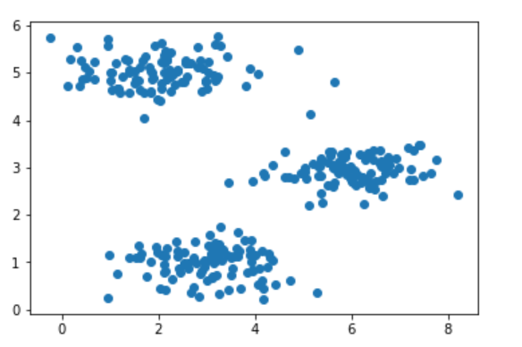

K = 3 #centroids

m_iters = 10

#initializes centroids with random values

def initialize_cents(data, K):

    m = data.shape[0]

    n = data.shape[1]

    cents = np.zeros((K,n))

    for i in range(K):

        cents[i] = data[np.random.randint(0,m+1),:]

    return cents

# finds the nearesr centroids

def nearest_cents(data, cents):

    idx = np.zeros([data.shape[0], 1])

    K = cents.shape[0] # num of centroids

    m = data.shape[0]

    #cost function

    for i in range(m):

        c = -1 # index of closest centroid

        min_distance = np.inf # distance to nearest centroid(np.inf is positive infinity)

        for k in range(K):

            dis = np.sum((data[i,:] - cents[k,:]) ** 2)

            if dis < min_distance:#swapping to find the closest centroid

                min_distance = dis

                c = k

        idx[i] = c

    return idx

first_cents = initialize_cents(data_n, K)

idx = nearest_cents(data_n, first_cents)

print('Nearest centroids:')

print(idx[0:3])

Output:

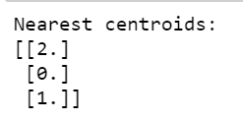Nearest centroids for a random initial centroids

#caluclates the new centroids

def calc_cents(data, idx, K):

    m, n = data.shape

    centroids = np.zeros([K, n])

    for k in range(K):

        C = np.sum(idx==k)

        idxk = (idx==k).astype(int)

        data_k = data * idxk

        # the mean of a new centroid is calculated here

        mn = (1/C) * np.sum(data_k, axis=0)

        centroids[k] = mn

    return centroids

centroids = calc_cents(data_n, idx, K)

print(centroids)

Output:

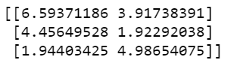New centroids for random initial centroids

def plt_k_means(data, idx, cents_history, terminated=False):

    cl1 = data_n[np.where(idx == 0)[0],:]

    cl2 = data_n[np.where(idx == 1)[0],:]

    cl3 = data_n[np.where(idx == 2)[0],:]

    fig, ax = plt.subplots(figsize=(5,5))

    ax.scatter(cl1[:,0], cl1[:,1], marker="o",facecolors="none",edgecolors="r", label='Cluster 1')

    ax.scatter(cl2[:,0], cl2[:,1], marker="o",facecolors="none",edgecolors="g", label='Cluster 2')

    ax.scatter(cl3[:,0], cl3[:,1], marker="o",facecolors="none",edgecolors="b", label='Cluster 3')

    ax.legend()

    plt.plot(cents_history[:, :, 0], cents_history[:, :, 1], 'x-', c='k')

    plt.show()

def k_means(data, init_cents, max_iters, plot_progress=False):

    m, n = data.shape

    K = init_cents.shape[0]

    centroids = init_cents

    idx = np.zeros([m, 1])

    cents_history = np.zeros([max_iters+1, centroids.shape[0], centroids.shape[1]])

    cents_history[0] = init_cents

    print('Before:')

    plt_k_means(data, idx, cents_history)

    #k means

    for i in range(max_iters):

        idx = nearest_cents(data, centroids)

        centroids = calc_cents(data, idx, K)

        cents_history[i+1] = centroids

        print('Iteration number: ', i+1)

        plt_k_means(data, idx,cents_history)

    return centroids, idx

centroids, idx = k_means(data_n, first_cents, m_iters)

Output:

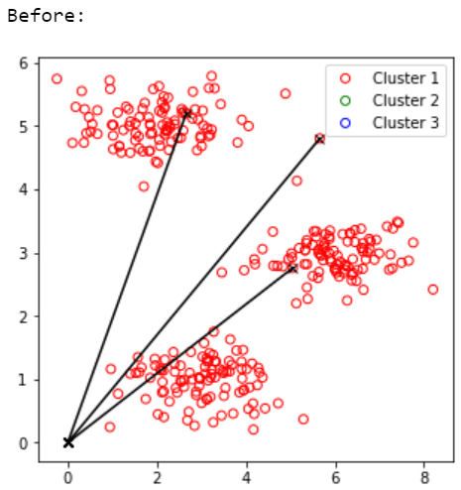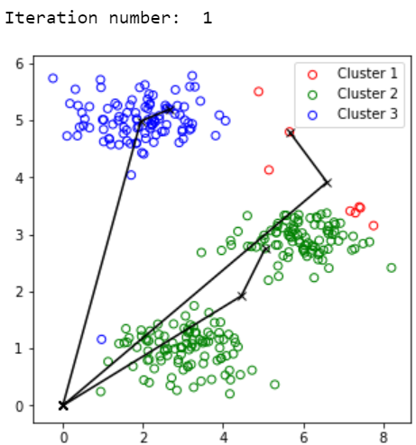

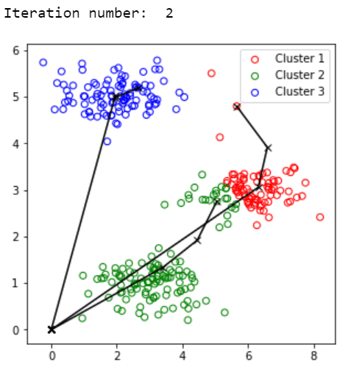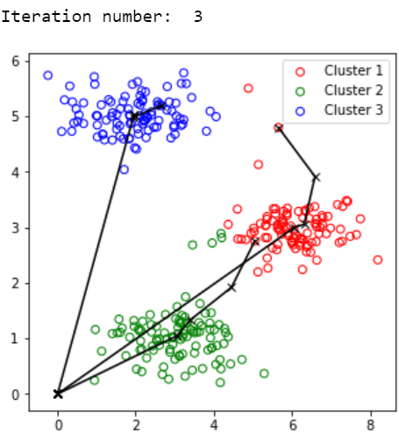

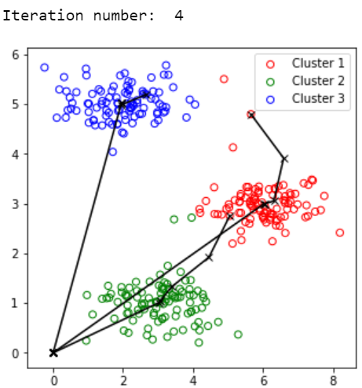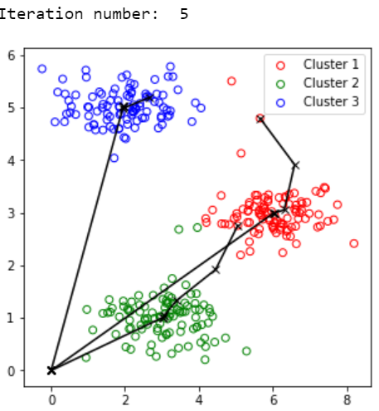

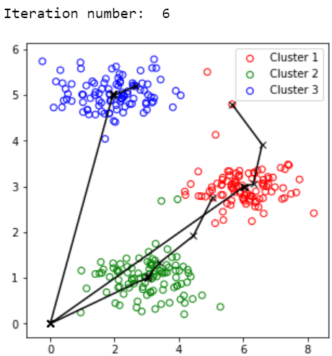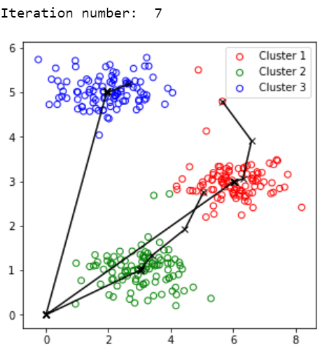

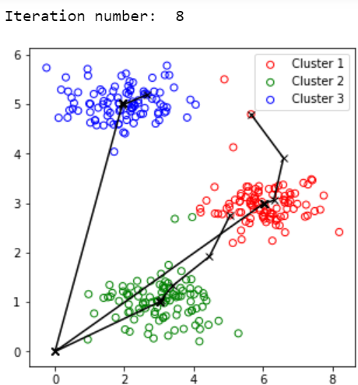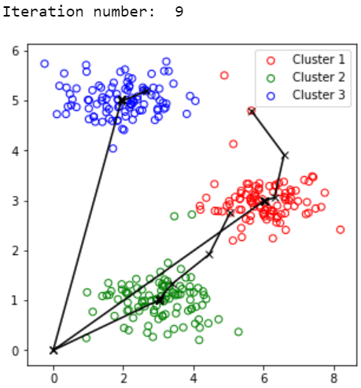

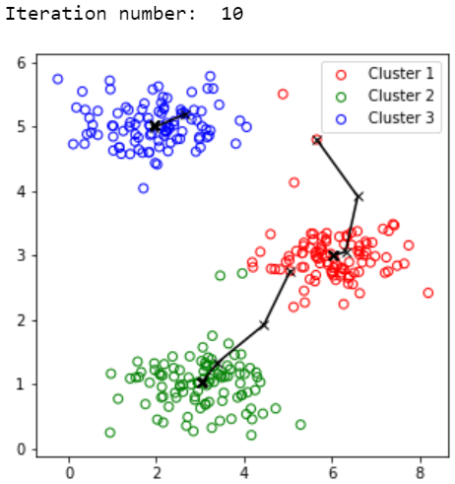

#to plot the graph that was in assignment instrcution pdf

first_cents = np.array([[3,3],[6,2],[8,5]])

idx = nearest_cents(data_n, first_cents)

print('Nearest centroids:')

print(idx[0:3])

Output:

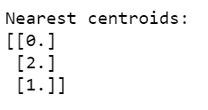Nearest centroids for the given samples

centroids = calc_cents(data_n, idx, K)

print(centroids)

Output:

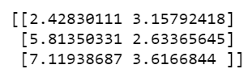

centroids, idx = k_means(data_n, first_cents, m_iters, plot_progress=True)

Output:

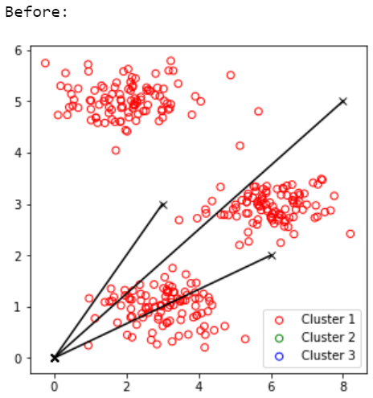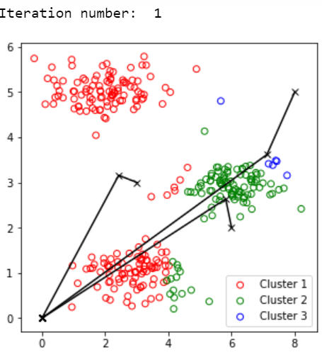

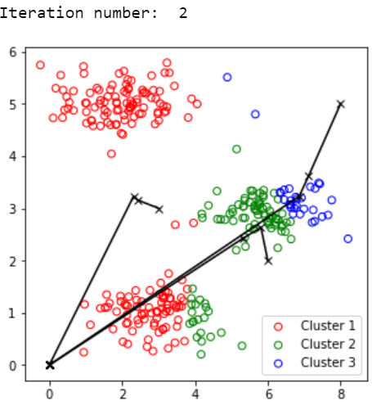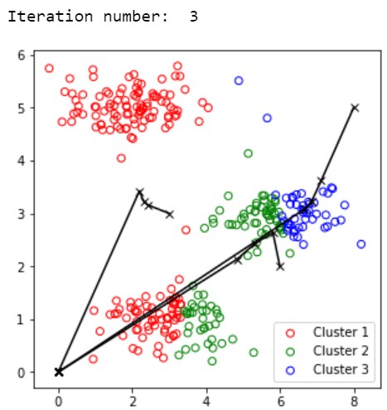

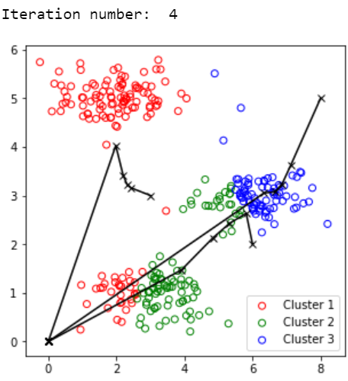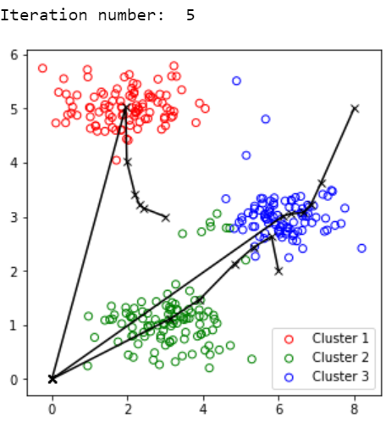

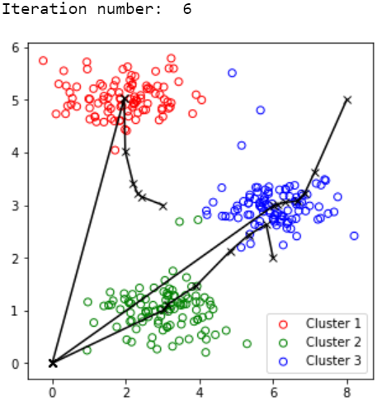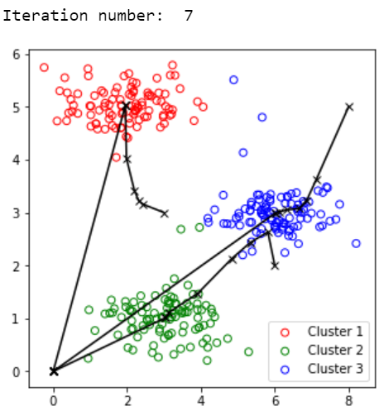

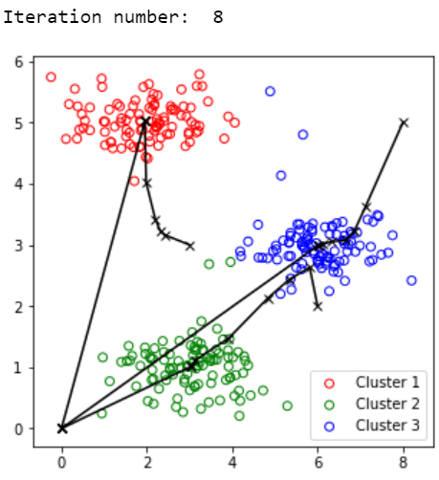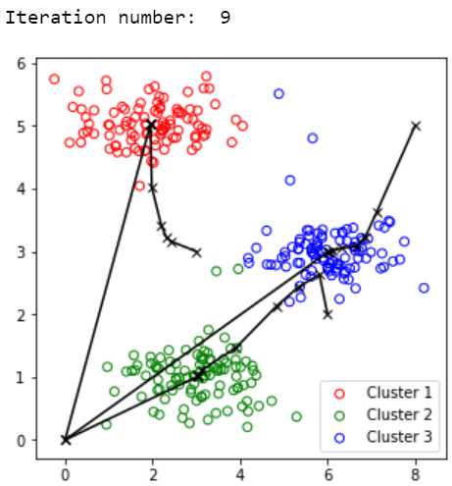

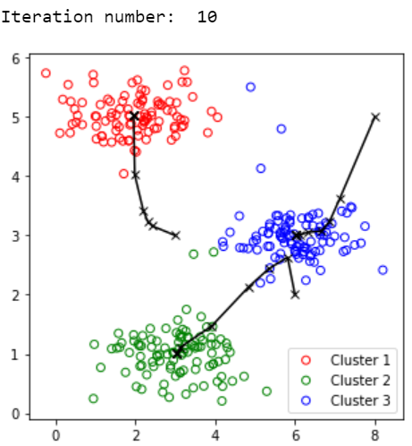Exactly the same as in as instructions pdf

#calculating the cost

for k in range (1, K+1):

    kmean= KMeans(n_clusters=k, random_state=1).fit(data_n[:, :])

    cost = kmean.inertia_

    print ("k:",k, " cost:", cost)

Output:

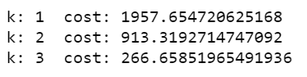Cost is decreasing which is good.

Using Library

#Kmeans using scikit-learn library

kmean = KMeans(n_clusters=3)

y_kmean = kmean.fit_predict(data_n)

print(y_kmean)

kmean.cluster_centers_

Output:

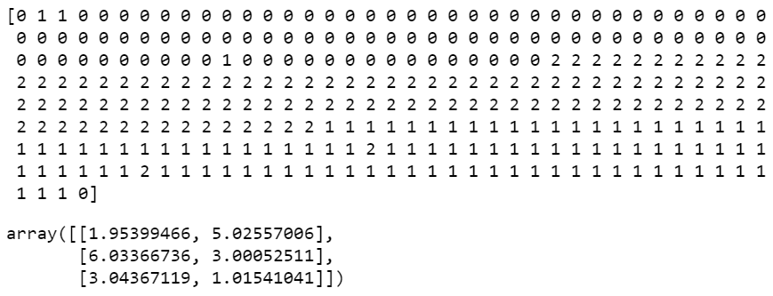

plt.scatter(data_n[:,0],data_n[:,1], c=y_kmean)

plt.scatter(

    kmean.cluster_centers_[:, 0], kmean.cluster_centers_[:, 1],

    s=100, marker='x',

    c='red', edgecolor='black',

    label='centroids'

)

Output:

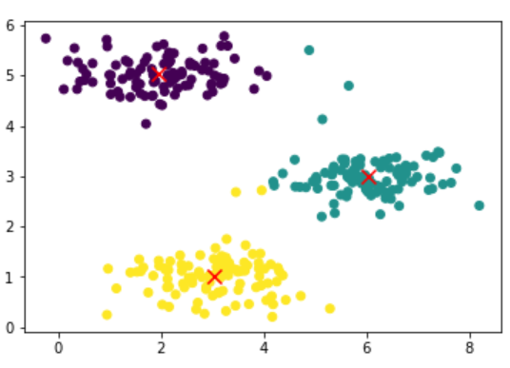

#Silhouette score

rg = list (range(2,11))

print ("Clusters num: ", rg)

for n_clusters in rg:

    clr = KMeans (n_clusters=n_clusters).fit(data_n)

    preds = clr.predict(data_n)

    centers = clr.cluster_centers_

    score = silhouette_score (data_n, preds, metric='euclidean')

    print (n_clusters, score)

Output:

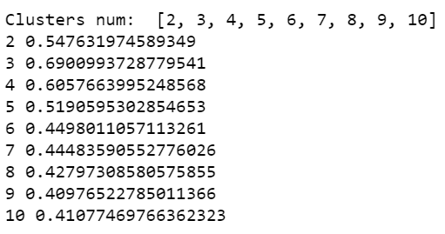

#Testing the data

kmean.predict([[0, 3], [5, 2]])

Output:



kmean.predict([[1, 1], [5, 2]])

Output:



kmean.predict([[5, 2], [2, 9]])

Output:



kmean.predict([[5, 3], [3, 3]])

Output:



kmean.predict([[6, 1], [2, 8]])

Output:

